AWS Infrastructure
What is Infrastructure (Infra)?
Infrastructure refers to the foundational components required to run applications and IT services.
Components of IT Infrastructure
Infrastructure typically includes:
- Servers – To run applications
- Storage – To store data
- Networking – To connect systems and users
- Operating Systems – To manage hardware
- Security – To protect systems and data
Traditional Infrastructure vs Cloud Infrastructure
Traditional (On-Premises) | Cloud (AWS)
Physical servers | Virtual servers
High upfront cost | Pay-as-you-use
Manual scaling | Auto scaling
Limited capacity | Unlimited capacity
High maintenance | AWS manages hardware

AWS Infrastructure
Amazon Web Services (AWS) provides cloud-based infrastructure,
- No need to buy physical servers
- Infrastructure is available on demand
- Highly secure and reliable
- Accessible from anywhere

What is an AWS Region?
An AWS Region is a geographical location where AWS has multiple data centers.
Each AWS Region is:
- Physically separate
Located in a different part of the world (for example: Mumbai, London, Virginia).
- Completely independent
Regions do not share power, cooling, or networking.
- Isolated from failures in other regions
Issues in one region do not affect other regions, ensuring high reliability.
Why AWS Uses Multiple Regions?
AWS regions help with:
Low Latency (Better Performance)
- Users get faster response times when services are hosted closer to their location
- Example:
Indian users → Mumbai region (ap-south-1)
✔ Faster website and application performance
Compliance & Data Residency Laws
- Many countries require data to stay within national borders
- AWS regions help organizations store and process data locally
✔ Meets government and industry regulations
✔ Important for banking, healthcare, and finance sectors
Disaster Recovery & Business Continuity
- If one region fails due to:
  - Natural disasters
  - Power outages
  - Network issues
- Applications can failover to another region
  - High availability
  - No single point of failure
Data Compliance Laws
- Ensures data is stored and processed according to:
  - Local laws
  - Industry standards
- Helps organizations pass security audits
✔ Legal compliance
✔ Strong governance
Summary Table
Benefit | Explanation
Low Latency | Faster access for nearby users
Compliance | Meets country-specific laws
Disaster Recovery | Backup across regions
Data Protection | Strong legal & security control
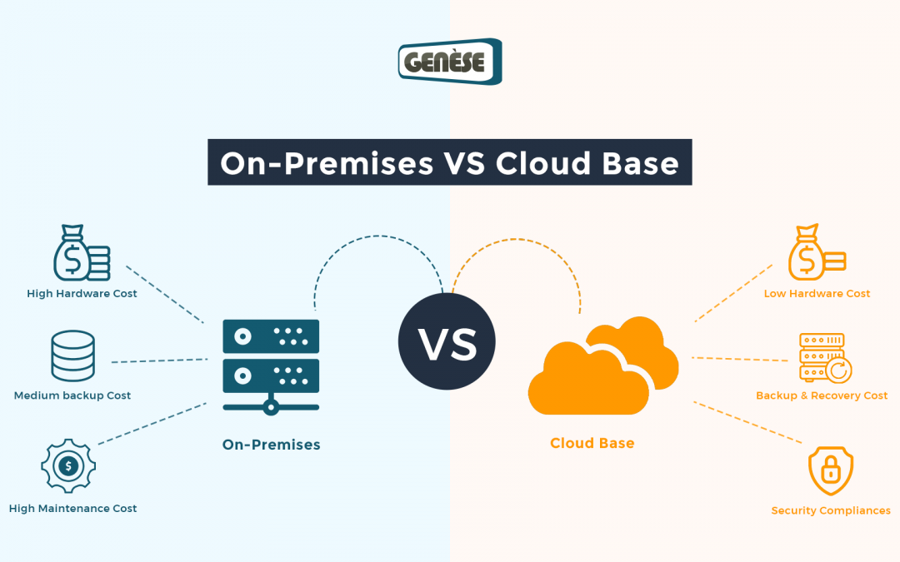
What are Availability Zones (AZs)?
Availability Zone (AZ) is one or more physically separate data centers located within a single AWS Region.
Each AZ is designed to be isolated from failures in other AZs, while still being connected through high-speed, low-latency networking.
Key Characteristics of Availability Zones
Each AZ has:
- Independent power supply
- Independent cooling
- Independent network connectivity
- Physical separation from other AZs
But AZs within the same region are connected using:
- High-speed private fiber networks
- Very low latency (milliseconds)
Simple Example
- Region → ap-south-1 (India -Mumbai Region)
- Availability Zones
    - ap-south-1a
    - ap-south-1b
    - ap-south-1c
These AZs are in different physical locations but within the Mumbai region.
Why Availability Zones Are Important?
Availability Zones help AWS provide:
High Availability : Applications continue running even if one AZ fails.
Fault Tolerance : Failures in one AZ do not affect others.
Disaster Protection : You can design systems that survive data center outages.

What is Virtualization?
Virtualization is a technology that allows multiple virtual machines (VMs) to run on one physical server.
Each VM has:
- Its own Operating System
- Dedicated CPU, memory, and storage (virtual)
- Independent applications
How Virtualization Works Internally
- Physical Hardware
  - CPU, RAM, Disk, Network Card
- Hypervisor (Virtualization Layer)
  - Sits between hardware and virtual machines
  - Divides physical resources
  - Allocates them to VMs
- Virtual Machines (VMs)
  - Each VM has:
    - Virtual CPU
    - Virtual RAM
    - Virtual Disk
    - Guest OS
  - Runs applications independently
What is a Hypervisor?
A hypervisor is a software layer that sits between physical hardware and virtual machines (VMs).
It allows multiple operating systems to run simultaneously on the same physical server.

Types of Hypervisors
There are Two types of hypervisors
1.Bare Metal Hypervisor
2.Hosted Hypervisor
1. Bare Metal Hypervisor
- Runs directly on hardware
- No host operating system
- High performance and security
- Used by AWS
Amazon Web Services uses Type-1 (bare-metal) hypervisors for better performance and security.
2.Hosted Hypervisor
- Runs on top of a host OS
- Used for personal or testing environments
Examples: VirtualBox, VMware Workstation
How a Hypervisor Works?
1.Hardware Layer
- Physical server contains:
  - CPU
  - RAM
  - Storage
  - Network interfaces
This is the real machine.
2.Hypervisor Layer
The hypervisor is installed directly on the hardware (Type-1) or on top of an OS (Type-2).
Its core responsibilities:
- Divides hardware resources
- Allocates resources to VMs
- Maintains isolation
- Manages VM lifecycle
Amazon Web Services uses Type-1 (bare-metal) hypervisors for better performance and security.
3.CPU Virtualization
- Physical CPU cores are split into vCPUs
- Hypervisor schedules CPU time for each VM
- Uses time-sharing (like a CPU scheduler)
4.Memory Virtualization
- Hypervisor assigns virtual RAM to each VM
- Maps virtual memory → physical memory
- Prevents one VM from accessing another VM’s memory
Strong isolation and stability
5.Storage Virtualization
- Physical disks are presented as virtual disks
- Each VM sees its own disk
- Hypervisor controls read/write operations
Data separation between VMs
6.Network Virtualization
- Creates virtual network interfaces
- Each VM gets a virtual NIC
- Hypervisor controls traffic flow
Secure communication between VMs
7.Isolation & Security
- Each VM runs independently
- If one VM crashes:
  - Other VMs are not affected
✔ Core requirement for cloud multi-tenancy

Why Hypervisors are Critical in AWS?
Hypervisors enable AWS to:
- Run millions of EC2 instances
- Share hardware safely between customers
- Scale on demand
- Ensure high performance & security
Without hypervisors → cloud computing is not possible.
Virtualisation in AWS
AWS uses (Bare Metal) Hypervisors to power services like:
- EC2 (Elastic Compute Cloud)
- Auto Scaling
- Load Balancing
AWS’s custom Nitro System offloads virtualization tasks to dedicated hardware, improving:
- Performance
- Security
- Isolation

Summary
- Infrastructure is the foundation of all IT systems
- AWS Regions provide geographic isolation
- Availability Zones ensure high availability
- Virtualisation enables multiple VMs on one server
- Hypervisors manage and isolate resources
- AWS infrastructure is scalable, secure, and fault-tolerant

